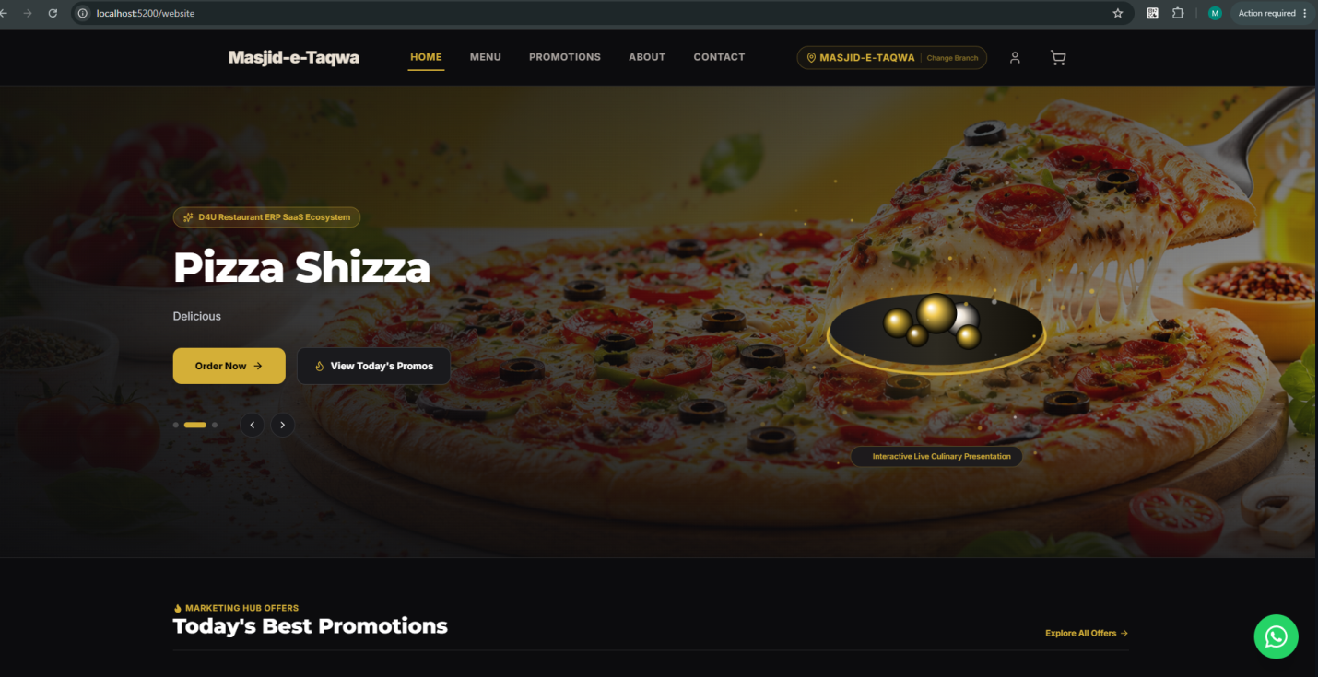
Slider Banner k opar jo button hein
Order Now
is per click karnay per Menu open hona chahiye hai
next jo button hai view Today’s Promos yaha click karnay per is website mein Promotions ka alag se page hai waha jana chahiye hai.
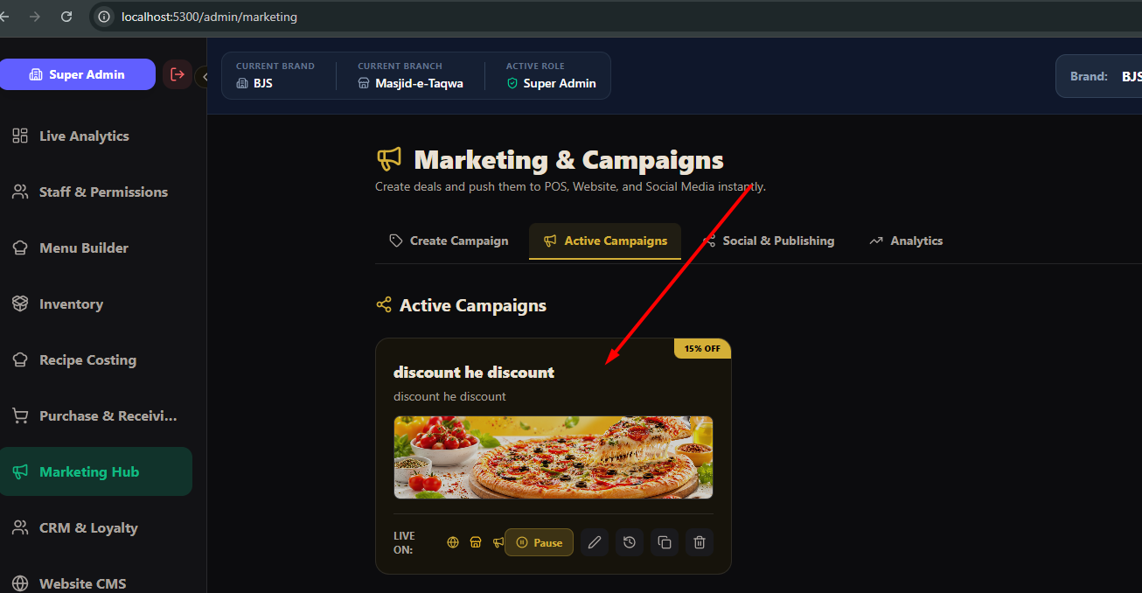
Marketing Hub mein jo Marketing Campaigns hein
jo Active Campaigns hein in ko website k
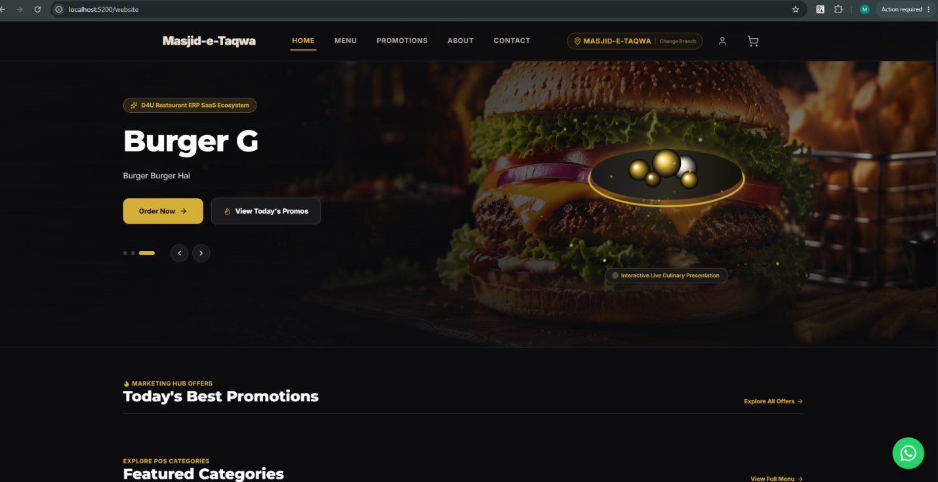
Home page per slider k neechay Marketing Hub Offers mein
Today’s Best Promotions yaha per show hona chahiye hai aur yaha kam az kam three promotions parallel ani chahiye hein
3 se zayada hoot u scroll slide chalna chahiye hai. jo promotions Today’s Best promotions mein ap show karo ge in ka big banners full details
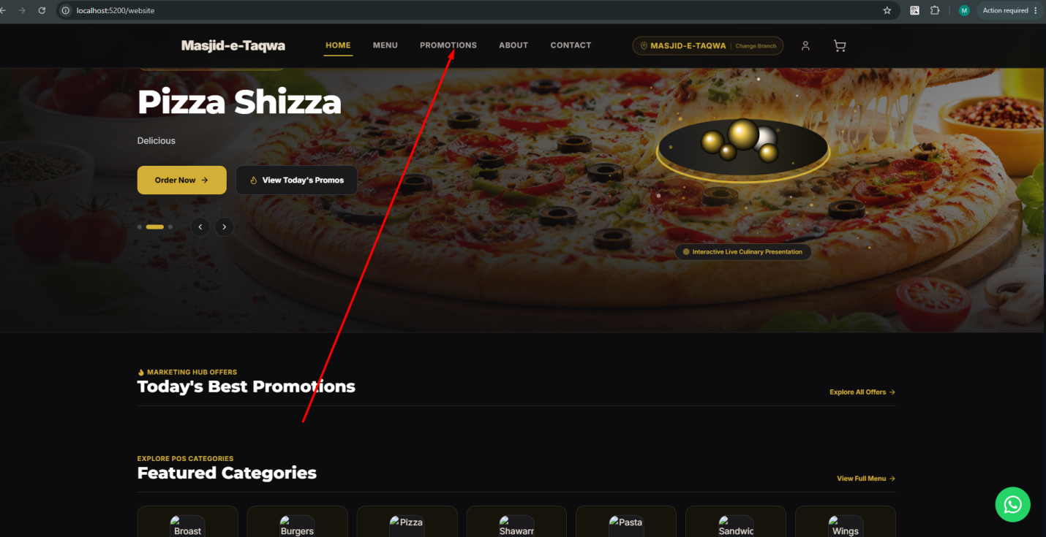
Jab promotions per click karay get u wo website k promotions walay page per le jaye ga
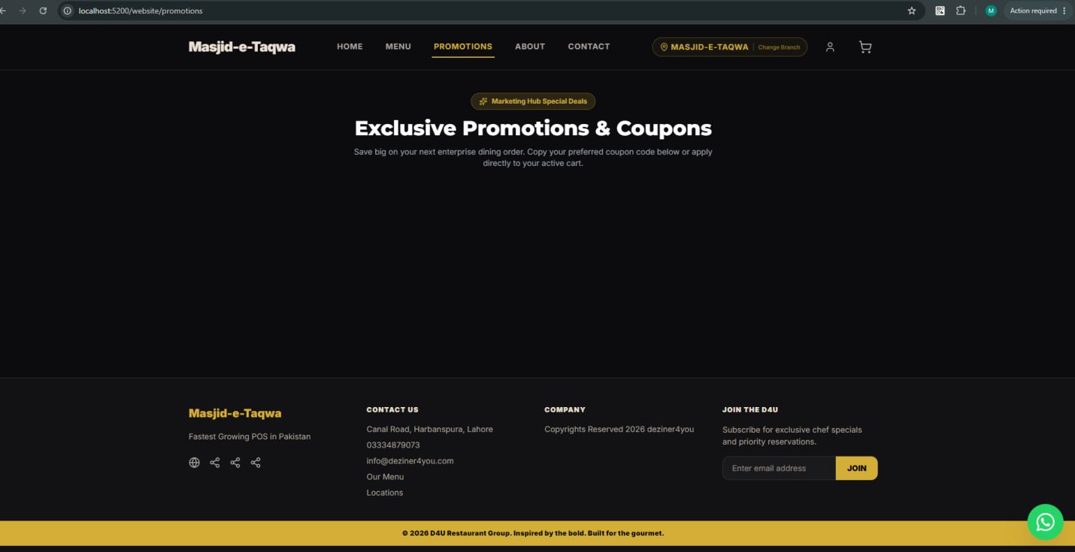
Is promotion walay page per promotions ki full banners aur neechay details hoo gi
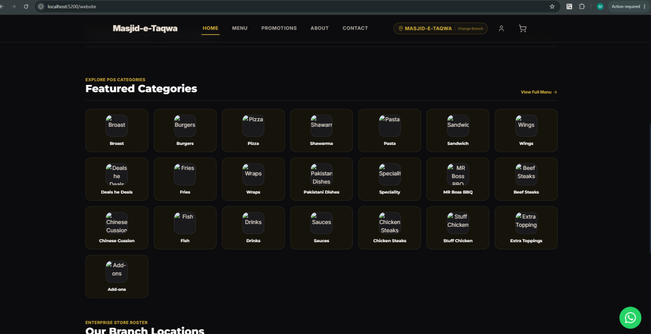
Is k neechay website k home per
Featured Categories hein
ye categories same wohi hein jo Catalogue mein hein but in per click karnay per website per mojod menu mein wo category load honi chahiye hai.
aur yaha catalogue ki sari categories nahi ani chahiye hein only wo categories ayein jo featured hoo.
is k liye backend per admin panel mein jaha menu hai waha category section mein category k sath aik tick box do k ye category featured hai ya nahi agar featured hai tu wohi featured categories yaha website per is section mein nazar ayein gi.
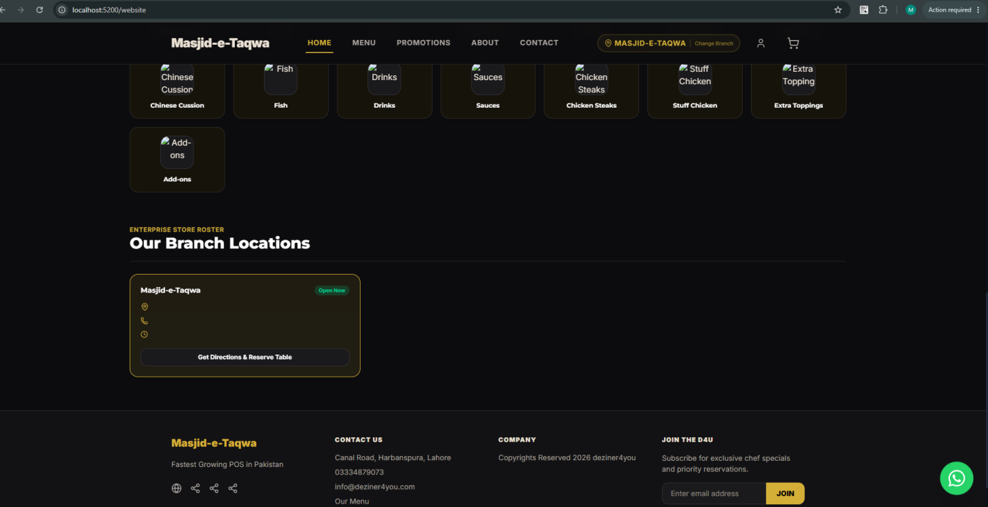
Home page per hai
Our Branch Locations
website k home page per ye jo section hai yaha brand k under jitni branches hein system wo sari branches ki locations ko yaha dikhaye ga chahay wo in city hoo ya out of city.
ye branches bhi 3 se zayada hoo gi tu scroll karein gi

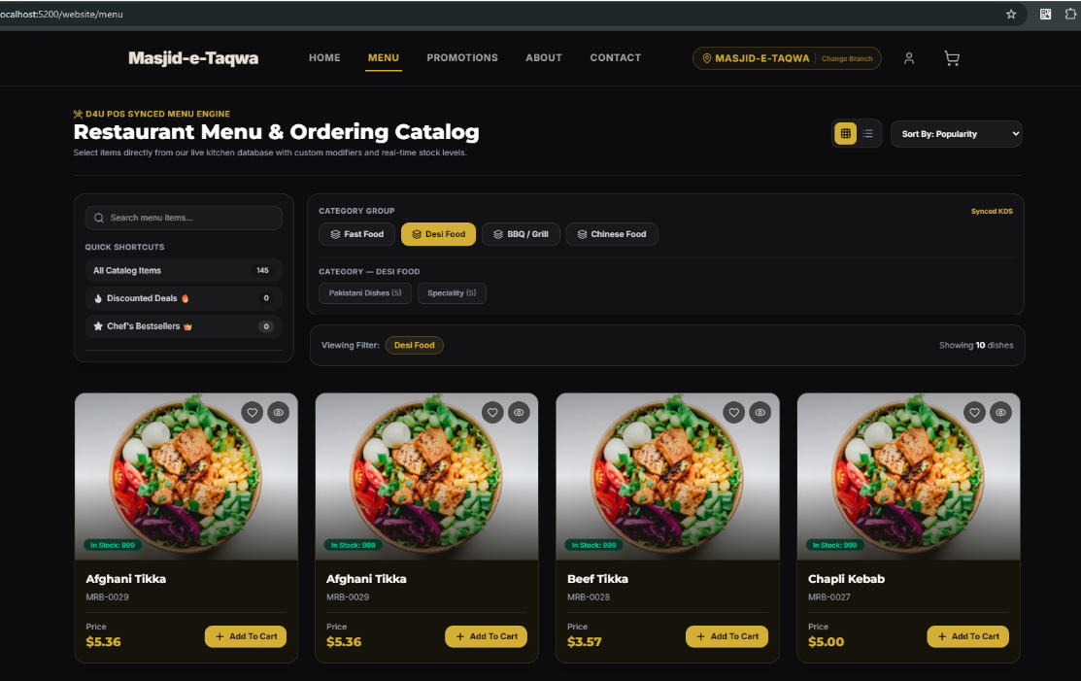
Change Website Home Page Catalogue Menu UI see my screen shoot.

